1

Seminar 7

1. In what way are the following sentences structurally amiguous?
   1. Squad helps dog bite victim
   2. Enraged cow injures farmer with axe
   3. Stolen painting found by tree
2. Label both the functions and the word classes in the following sentences?
   1. John offered to lend his neighbour a hand
   2. Without any doubt he was guilty of murder
   3. I find Jack a little tiresome to be honest
3. Identify the subordinate clauses in the following sentences.
   1. For each sentence, draw a line under the dependent clause(s).
   2. For each dependent clause, write a brief description of the role/function of that dependent clause. For clauses which are complements (Od, Oi, Cs, Co), which word are they the complement of? For modifying clauses (A and PMod), what do they modify?
   3. Put a box around subordinating words, and a circle around coordinating words.
   4. Jack suddenly remembered that he had left his wallet in the car
   5. When he stepped on the train he suddenly realised that he had left his pack lunch at

home

* 1. Whoever tried to steal Chen’s car caused a lot of damage to the steering wheel
  2. The cake his friend made him was covered in almonds
  3. Fatimeh was surprised that the tea tasted bitter

1. Clinical materials / data

Look at the following picture prompts which belong to standardised assessments. Write an ideal response (ie what sentence does the child need to produce, or what picture do they need to point to). Then describe the “linguistic ability” that is being assessed?

When describing the “linguistic ability” try to use linguistic terminology which has been introduced in the lectures, and refer to specific word classes or constructions you have come across, e.g. “the ability to use prepositions”, “the ability to use the Verb Phrase”, or “the ability to use the superlative construction”.

Answers should be between one and three sentences long depending on what abilities are being measured

NB there are two items for you to practice. The actual exam will have four

* 1. What is the boy doing?

1

2 *CHAPTER 1. SEMINAR 7*

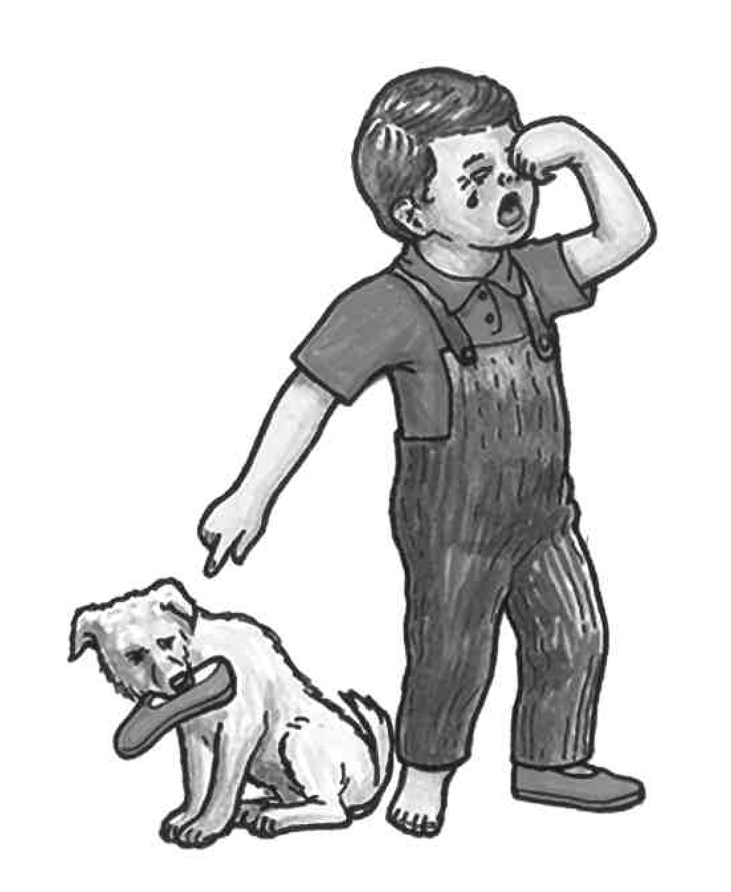

TARGET RESPONSE:

WHAT LINGUISTIC ABILITIES ARE BEING ASSESSED?

b) What do you think has happened?

3



TARGET RESPONSE:

WHAT LINGUISTIC ABILITIES ARE BEING ASSESSED?